VACCUM CLEANER PROBLEM

AIM: To implement python program for vaccum cleaner problem.

OBJECTIVES:
- To simulate the working of a simple Vacuum Cleaner Agent in Artificial Intelligence.
- To clean all dirty rooms in the environment automatically.
- To demonstrate the concept of a simple reflex agent that senses the environment and performs appropriate actions.
- To ensure that every room becomes clean by moving between rooms and cleaning them when necessary.

ALGORITHM:
- Start the program.
- Create two rooms (A and B) and mark their initial status (Dirty/Clean).
- Place the vacuum cleaner in Room A.
- Display the initial status of both rooms.
- Check if the current room is dirty.
- If the room is dirty, clean it; otherwise, leave it unchanged.
- Move the vacuum cleaner to the other room.
- Repeat Steps 5–7 until all rooms are clean.
- Display the final status of all rooms.
- Stop the program.

SYSTEM ARCHITECTURE:
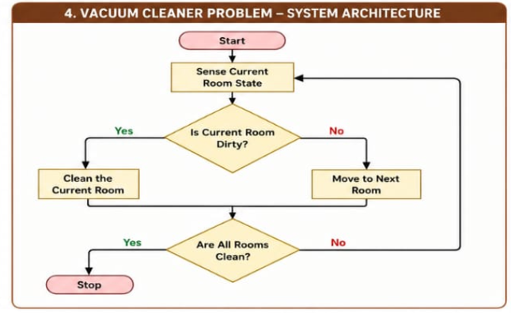

PROGRAM:
# Vacuum Cleaner Problem

room = {
"A": "Dirty",
"B": "Dirty"
}

position = "A"

print("Initial Room Status:", room)

while "Dirty" in room.values():
print("Vacuum cleaner is at", position)

if room[position] == "Dirty":
print("Cleaning room", position)
room[position] = "Clean"
else:
print("Room is already clean")

if position == "A":
position = "B"
else:
position = "A"

print("Final Room Status:", room)
print("All rooms are clean")

OUTPUT:
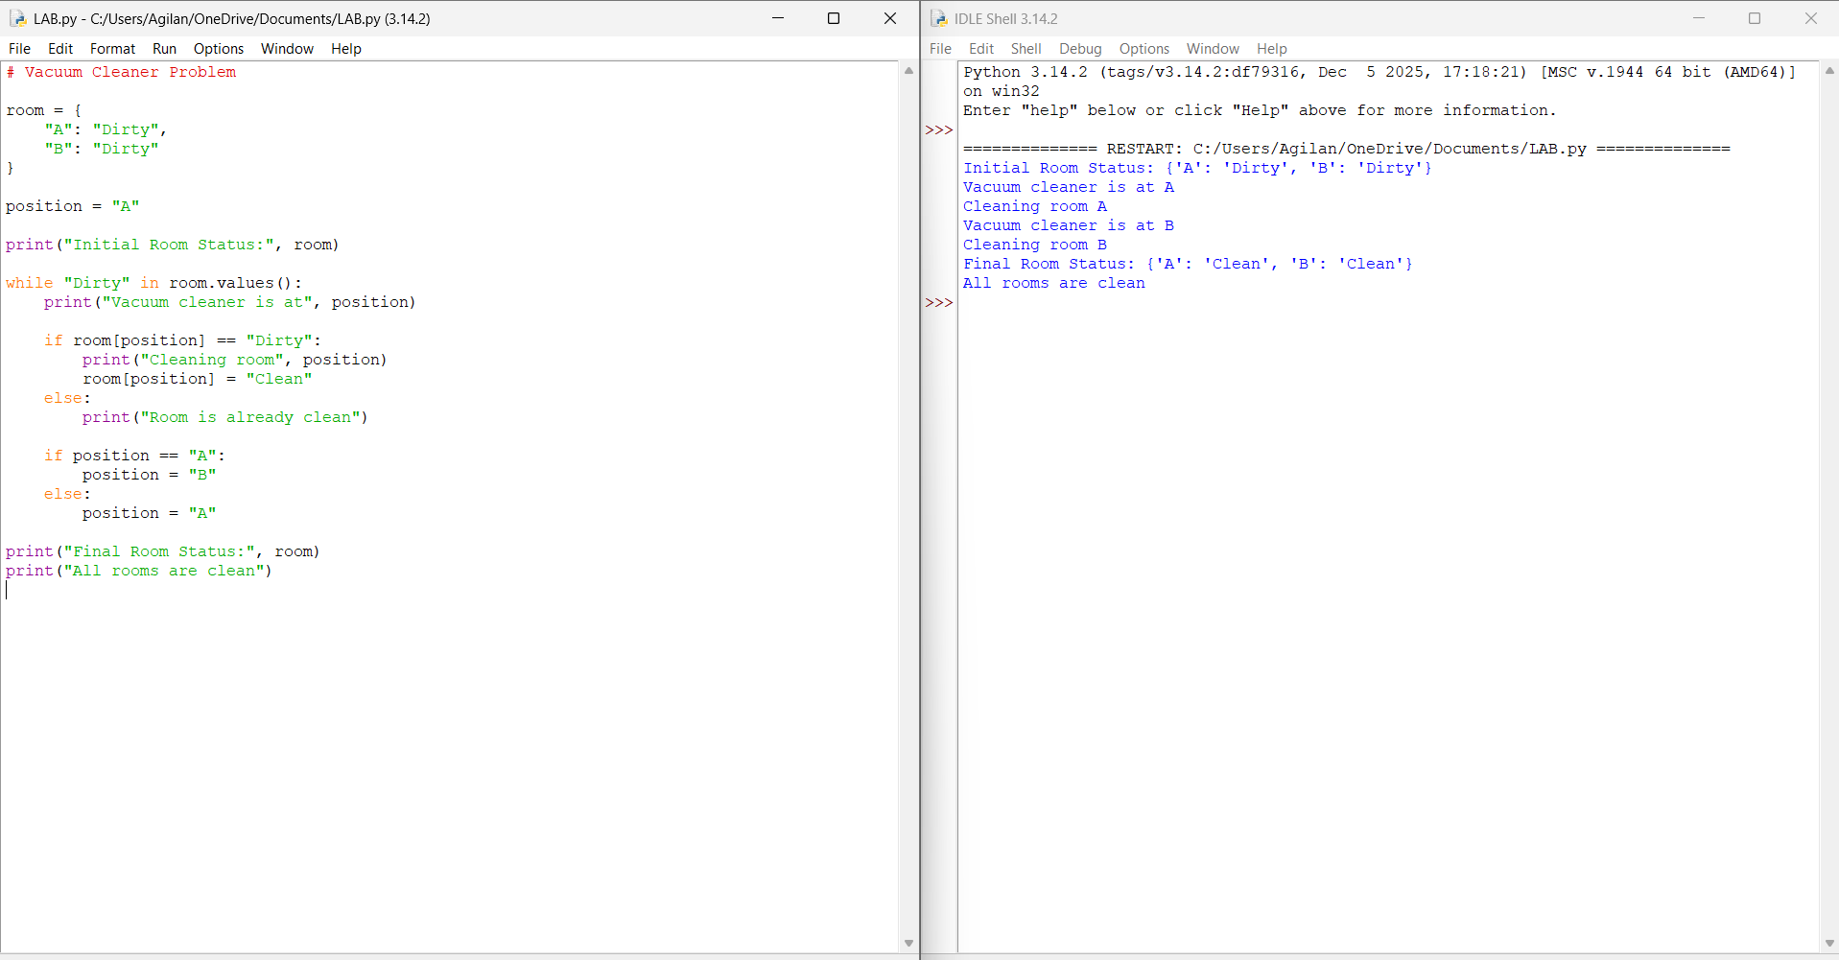

RESULT: Thus the Vaccum Cleaner problem is implemented successfully using python language.

